The Catechesis
Of the Good
Shepherd

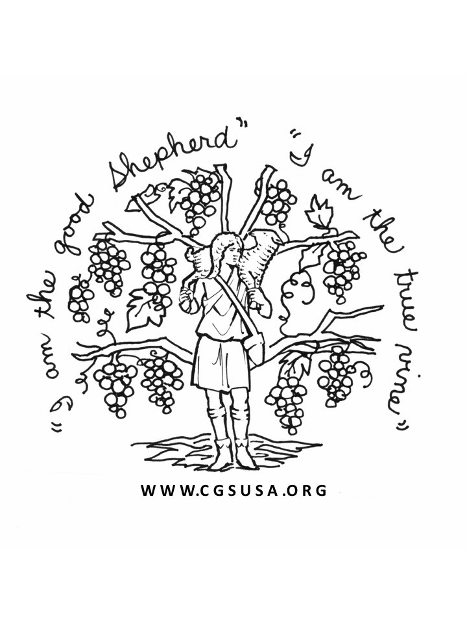

Level One (3-6)
Catechist Formation
Course

St. Robert Bellarmine
214 E. Henry Street
Flushing, MI 48433

Course Logistics
The course will be held at St. Robert Bellarmine Church, in Flushing, Michigan. The facilities allow for both classroom space and access to a full 3-6 atrium. Breakfast, lunch and snacks will be provided. Class closed at 30 participants.

Course Dates
June 3-4, 6-9, 2022 (Part One)
June 5-10, 2023 (Part Two)

Course Leaders
Pam Turchi
Hannah Turchi

For More Information
Contact: Clare Pulley
(810) 659-8556
cpulley@strobertschool.com

Registration Form

Name:_________________________________

Address:________________________________

_______________________________________

Phone: ________________________________

E-Mail: ________________________________
Parish/School
Affiliation:______________________________

Are you hoping to work on making Level 1 materials as part of the course? ____________

Please make checks or money orders payable to St. Robert Bellarmine (attn.3-6 Training).

Tuition for the course is $200.00 (part one) and $200 (part two); Please send registration form with $100 deposit by May 6, 2022 to:

Clare Pulley
St. Robert Bellarmine
310 N. Cherry Street
Flushing, MI 48433

About the Catechesis of the Good Shepherd
The Catechesis of the Good Shepherd is an approach to the religious formation of children, 3-12 years of age. It originated in 1954 with the founding of the children’s center or “atrium” in Rome by Sofia Cavalletti, a biblical scholar, and Gianna Gobbi, an educator of children and teachers. Inspired by Montessori principles of education, the catechesis is based on the conviction that God and the child are already in relationship.
The goal of Level One (ages 3-6) of The Catechesis of the Good Shepherd is to help the child enjoy and be in love with God, first proclaimed as Jesus, the Good Shepherd. Such a relationship is the strongest possible foundation for life-long spiritual growth and moral living.
Children hear the Gospel by working with sensorially rich, but simple materials, keyed to scriptural or liturgical moments. Central to this program is the Atrium, a sacred space prepared for the children. A place of beauty, the atrium is designed for being with and enjoying God, listening to God’s Word, and praying.
Implementation of the Catechesis of the Good Shepherd requires training for adults at each level or age group: Level One focuses on children ages 3-6. The training course features 90 hours of lectures, participation in discussions, lesson presentations, and assistance with preparing materials and the catechist’s album. The Level One course is foundational for all three levels of CGS.
At the end of this course, the participants will receive certification for Level 1 from the National Association of the Catechesis of the Good Shepherd. (www.cgsusa.org)
3-6 Course Objectives
- To explore the religious nature and the most vital religious needs of the 3-6 year old child.
- To present the methodology and guiding principles of the Catechesis of the Good Shepherd.
- To broaden the catechist’s ability to observe and learn from children, to listen with children to scripture and to deepen the catechist’s enjoyment of God’s presence.
- To offer guidelines and assistance in preparing the “atrium” environment, developing the catechist’s teaching album, and making catechetical materials.
- To meditate on the scriptural and liturgical themes presented to the 3-6 year old.

The Formation Leaders
Pam Turchi has been involved in Catechesis of the Good Shepherd since 2007. She assisted in building Level I, II and III at St. Robert in Flushing, has been a catechist in all three atria, and was certified as a Level One Formation Leader in 2018.

Hannah Turchi began her journey with Catechesis of the Good Shepherd in 2011, and is a catechist and Director of Religious Education at St. Robert Bellarmine, Flushing. In 2018, Hannah was certified as a Level One Formation Leader. She is has a masters degree in Pastoral Studies and Catechesis of the Good Shepherd (MAPS-CGS) from Aquinas Institute in St. Louis, MO.

Tuition and Texts
The tuition for the entire course is $400. The tuition includes the $35 registration fee for the National Association of the Good Shepherd.

There are three required texts for the course:
- The Religious Potential of the Child (Sofia Cavalletti)
- Listening to God with Children (Gianna Gobbi)
- The Good Shepherd and the Child, A Joyful Journey.

These texts can be ordered from the National Association of the Catechesis of the Good Shepherd. An order form may be obtained from their web site: www.cgsusa.org. Phone 708-524-1210. Texts can also be purchased from Liturgical Training Publications at www.ltp.org.

Also highly recommended to purchase:
- The Catechesis of the Good Shepherd in a Parish Setting (by Tina Lillig)
- The Development of the Catechesis of the Good Shepherd (by Sofia Cavalletti).

