The Catechesis
Of the Good
Shepherd

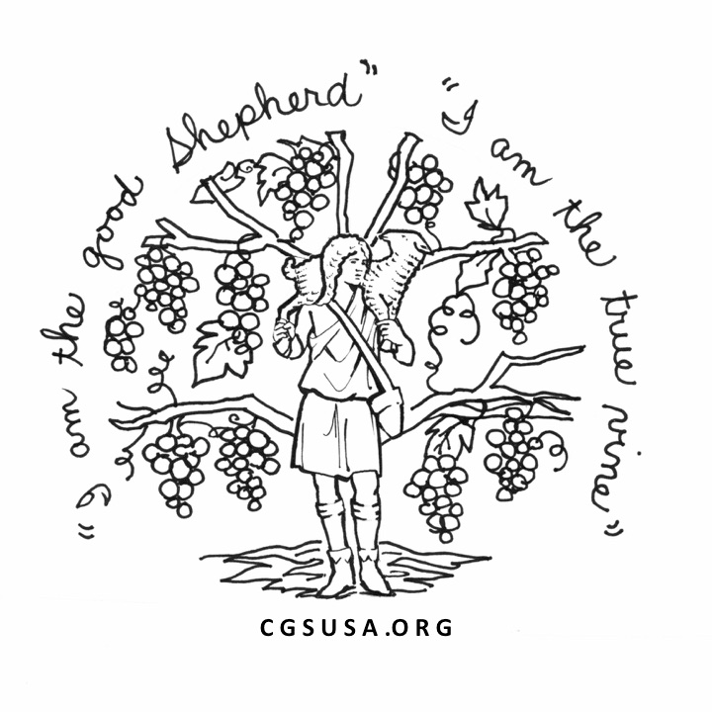

Level Two (6-9)
Catechist Formation
Course

St. Robert Bellarmine
214 E. Henry Street
Flushing, MI 48433

Course Logistics

The course will be held at St. Robert Bellarmine Church, in Flushing, Michigan. The facilities allow for both classroom space and access to a full 6-9 atrium. Course days begin at 9:00 a.m. and will end about 4:00 p.m. Breakfast, lunch and snacks will be provided on all days.
Class closed at 24 participants.

Course Dates
Part I: July 27-30, August 1-3, 2022
Part II: August 3-5, 7-10, 2023

Course Leaders
Katy Beedle Rice

For More Information
Contact: Hannah Turchi
(810) 659-8556
hturchi@strobertschool.com

Registration Form
Name:_________________________________

Address:_______________________________________________________________________

Phone: ________________________________

E-Mail: ________________________________

Parish/School: _______________________________________
What year did you complete Level 1 formation, and who were your formation leaders? ______________________________________________________________________________
Do you currently serve in an atrium? If so, where? At what level?
____________________________________

Are you hoping to work on making Level 2 materials as part of the course? ____________

Please make checks or money orders payable to St. Robert Bellarmine (attn.6-9 Training).

Send registration form with $100 deposit by June 30, 2022 to:

Hannah Turchi, DRE
St. Robert Bellarmine
310 N. Cherry Street
Flushing, MI 48433
About the Catechesis of the Good Shepherd
The Catechesis of the Good Shepherd is a Montessori-based religious formation program for children, beginning at the age of three. It seeks to create and facilitate a sacred, “hands-on” environment for children called an atrium, in which both the children and the catechists can hear, ponder, and celebrate the most essential mysteries of the Christian faith as revealed in the Scriptures and Liturgy. Originally developed in Rome by Dr. Sofia Cavalletti and Gianna Gobbi in 1954, the Catechesis has since spread worldwide. Though Roman Catholic in its origin it is now adapted to be used in several denominations.

Catechist Formation
There are three levels of training for those interested in the Catechesis of the Good Shepherd: Level 1 – for children ages 3-6; Level 2 – for ages 6-9 and Level 3 – for ages 9-12. Each level involves approximately 100 hours of meditations, presentations, and album page assistance. It also includes some observation time in an atrium. At the end of this course, the participants will receive certification for Level 2 from the National Association of the Catechesis of the Good Shepherd. (www.cgsusa.org)

6-9 Course Objectives
- To explore with participants the general developmental and religious characteristics of the 6 – 9 year old child
- To facilitate further meditation on the biblical and liturgical themes of the Catechesis
- To offer guidelines and assistance to catechists for setting up an atrium for 6-9 year olds, preparing an album, and making materials
- To deepen participants’ ability to observe and learn from children
- To aide in the formation of a community of catechists

The Formation Leaders

Katy is a recognized Level 1 and Level 2 formation leader with the National Association of the Catechesis of the Good Shepherd. For 11 years Katy served as the Director of Religious Education at the Cathedral of the Nativity of the Blessed Virgin Mary in Juneau, Alaska. During that time she led her parish in establishing atria to serve all the parish’s children from ages 3 to 12. Currently, Katy lives in Boise, Idaho, where she volunteers as a catechist for children ages 3-12 and works in a primary Montessori school. In May 2017 she graduated from Aquinas Institute of Theology in St. Louis, Missouri with a Masters in Pastoral Studies with a concentration in the Catechesis of the Good Shepherd. In 2021 Katy received her certification as a Montessori Guide for 3 to 6 year-old children. Katy brings with her great enthusiasm for this work and a love of living the religious life with children in the atrium. She
and her husband have three children.

Tuition and Texts
The tuition for the entire course that spans two sessions is $700. This may be paid in two payments of $350 for Part I and $350 for Part II. The tuition includes the $35 registration fee for the National Association of the Good Shepherd.

The required reading for the course:
- The Religious Potential of the Child – vol. 2 by Sofia Cavalletti
- The History of the Kingdom of God: From Creation to Parousia (Part One) by Sofia Cavalletti
- The History of the Kingdom of God: Liturgy and the Building of the Kingdom (Part Two) by Sofia Cavalletti
- Life in the Vine by Rebekah Rojcewicz

Highly recommended texts to purchase:
- Ways to Nurture the Relationship with God by Sofia Cavalletti & Patricia Coulter
- Children who are not yet Peaceful by Donna Bryant Goertz

These texts can be ordered from the National Association of the Catechesis of the Good Shepherd. An order form may be obtained from their web site: www.cgsusa.org. Phone 708-524-1210. Texts can also be purchased from Liturgical Training Publications at www.ltp.org.

